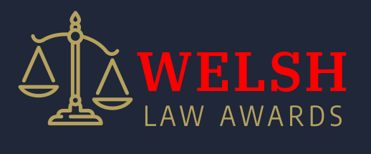

Welsh Law Awards
Thursday 9th October 2025
Categories

- Commercial Law Services of the Year
- Employment Law Services of the Year
- Family Law Services of the Year
- Personal Injury Law Services of the Year
- Residential Conveyancing Law Services of the Year
- Conveyancer of the Year
- Solicitor of the Year (1-4 Years)
- Solicitor of the Year (+5 Years)
- Paralegal of the Year
- Legal PA of the Year
- Private Client Law Services of the Year

- Welsh Law Awards – Champion 2025 (Drawn from the winners of the categories above)

Entry criteria
- Must be based or operate in Wales
- Will need to provide details in the application form, in accordance with the entry criteria of the specific category.
- Applications will be accepted from Wednesday 18th June 2025
- All applicants must have applied for entry no later than Friday 5^{h} September 2025.
- Applicants will be shortlisted and notified no later than Monday 8th September 2025
- The awards will be held on Thursday 9th October 2025 at the Hilton Hotel – Cardiff.

Award Prizes
- Each nominee will receive a certificate of finalist status.
- Each category winner will receive a commemorative trophy.
- Each category winner will be included within the Welsh Law Awards results PR campaign.

Copyright WS Marketing 2025

